**WEEK 5 MICRO SERVICES HANDS_ON EXERCISES**

**EXERCISE 1:** Creating Microservices for account and loan

**Account Microservice**

**AccountController.java:**

**package** com.cognizant.account.controller;

**import** org.springframework.web.bind.annotation.GetMapping;

**import** org.springframework.web.bind.annotation.PathVariable;

**import** org.springframework.web.bind.annotation.RestController;

**import** java.util.Map;

@RestController

**public** **class** AccountController {

@GetMapping("/accounts/{number}")

**public** Map<String, Object> getAccountDetails(@PathVariable String number) {

**return** Map.*of*(

"number", number,

"type", "savings",

"balance", 234343

);

}

}

**AccountApplication.java:**

**package** com.cognizant.account;

**import** org.springframework.boot.SpringApplication;

**import** org.springframework.boot.autoconfigure.SpringBootApplication;

@SpringBootApplication

**public** **class** AccountApplication {

**public** **static** **void** main(String[] args) {

SpringApplication.*run*(AccountApplication.**class**, args);

}

}

**Output:**

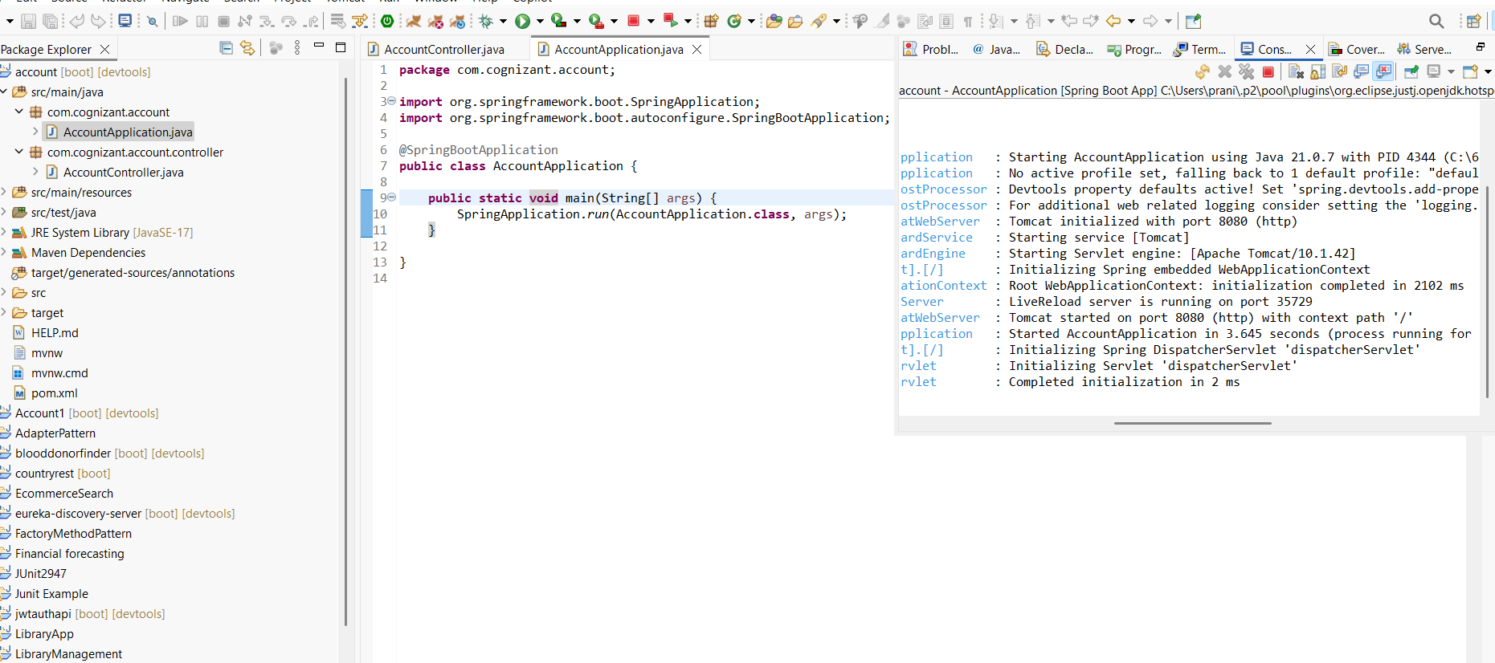

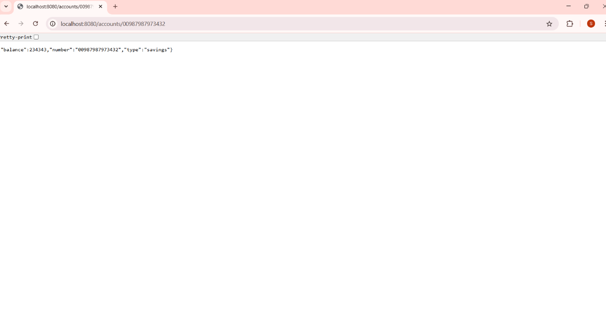**Browser**

**Loan microservice:**

**LoanController.java:**

**package** com.cognizant.loan.controller;

**import** org.springframework.web.bind.annotation.GetMapping;

**import** org.springframework.web.bind.annotation.PathVariable;

**import** org.springframework.web.bind.annotation.RestController;

**import** java.util.Map;

@RestController

**public** **class** LoanController {

@GetMapping("/loans/{number}")

**public** Map<String, Object> getLoanDetails(@PathVariable String number) {

**return** Map.*of*(

"number", number,

"type", "car",

"loan", 400000,

"emi", 3258,

"tenure", 18

);

}

}

**LoanApplication.java:**

**package** com.cognizant.loan;

**import** org.springframework.boot.SpringApplication;

**import** org.springframework.boot.autoconfigure.SpringBootApplication;

@SpringBootApplication

**public** **class** LoanApplication {

**public** **static** **void** main(String[] args) {

SpringApplication.*run*(LoanApplication.**class**, args);

}

}

**Output:**

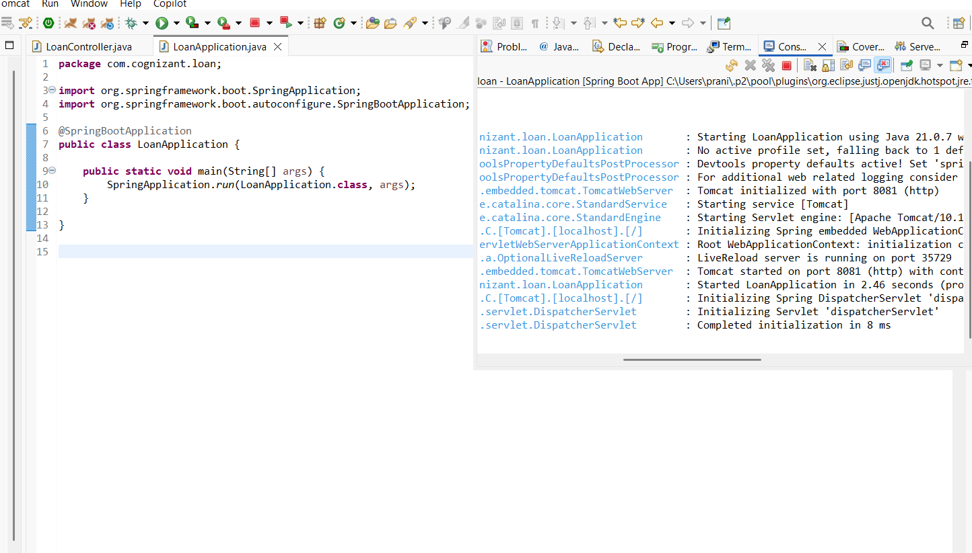

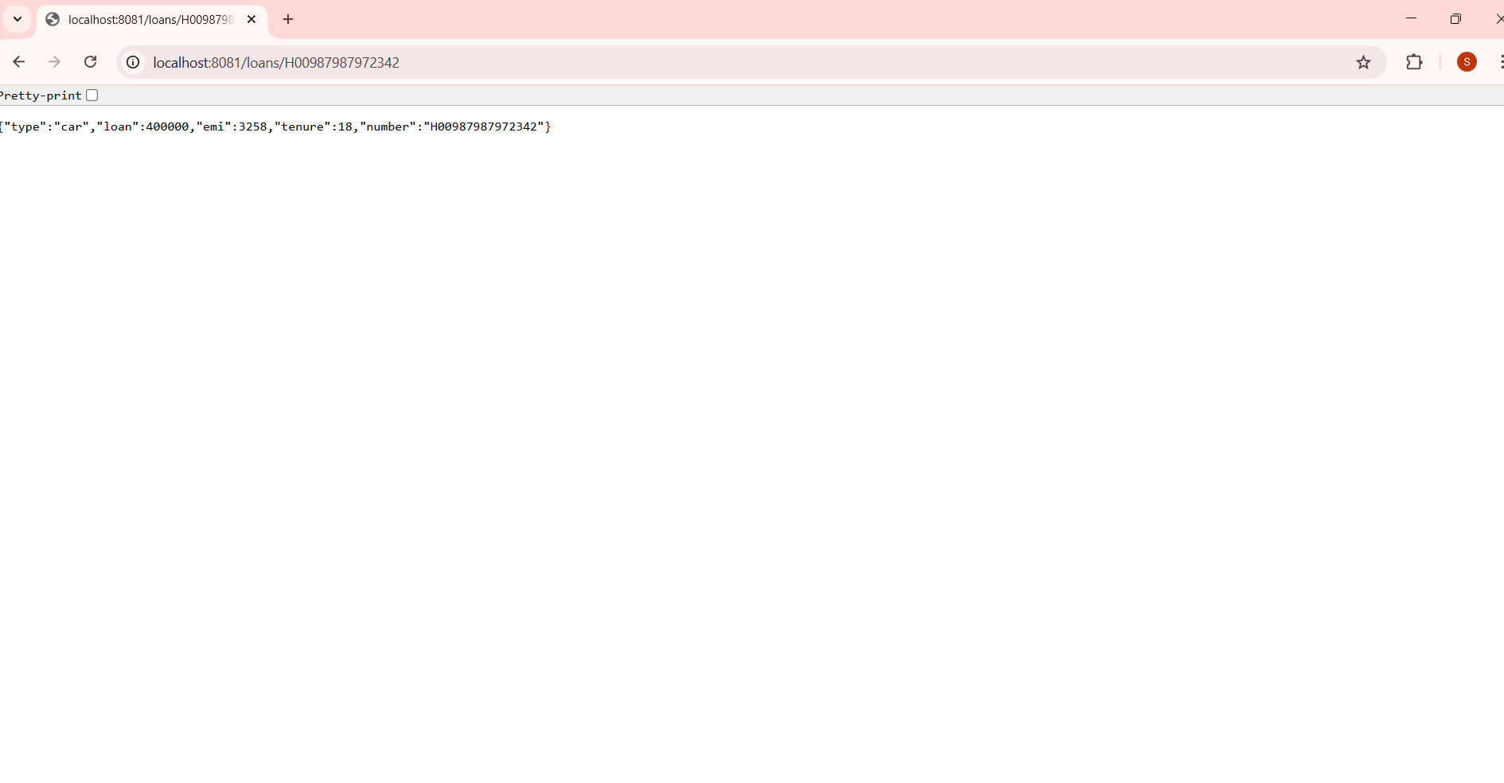**In Browser:**

**ADDITIONAL EXPERIMENTS:**

**Create Eureka Discovery Server and register**

**EurekaDiscoveryServerApplication.java:**

**package** com.cognizant.eureka_discovery_server;

**import** org.springframework.boot.SpringApplication;

**import** org.springframework.boot.autoconfigure.SpringBootApplication;

**import** org.springframework.cloud.netflix.eureka.server.EnableEurekaServer;

@SpringBootApplication

@EnableEurekaServer

**public** **class** EurekaDiscoveryServerApplication {

**public** **static** **void** main(String[] args) {

SpringApplication.*run*(EurekaDiscoveryServerApplication.**class**, args);

}

}

**application.properties:**

server.port=8761

eureka.client.register-with-eureka=false

eureka.client.fetch-registry=false

logging.level.com.netflix.eureka=OFF

logging.level.com.netflix.discovery=OFF

**OUTPUT:**

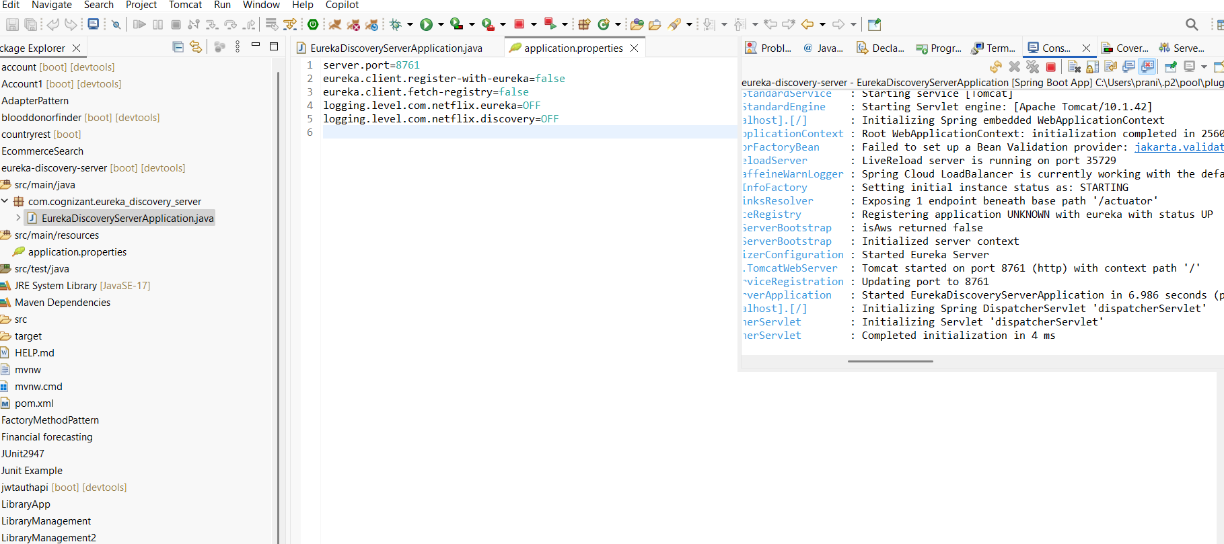

**For Account:**

**AccountApplication.java:**

**package** com.cognizant.Account1;

**import** org.springframework.boot.SpringApplication;

**import** org.springframework.boot.autoconfigure.SpringBootApplication;

**import** org.springframework.cloud.client.discovery.EnableDiscoveryClient;

@SpringBootApplication

@EnableDiscoveryClient

**public** **class** Account1Application {

**public** **static** **void** main(String[] args) {

SpringApplication.*run*(Account1Application.**class**, args);

}

}

**application.properties:**

server.port=8080

spring.application.name=account-service

eureka.client.service-url.defaultZone=http://localhost:8761/eureka

**Output:**

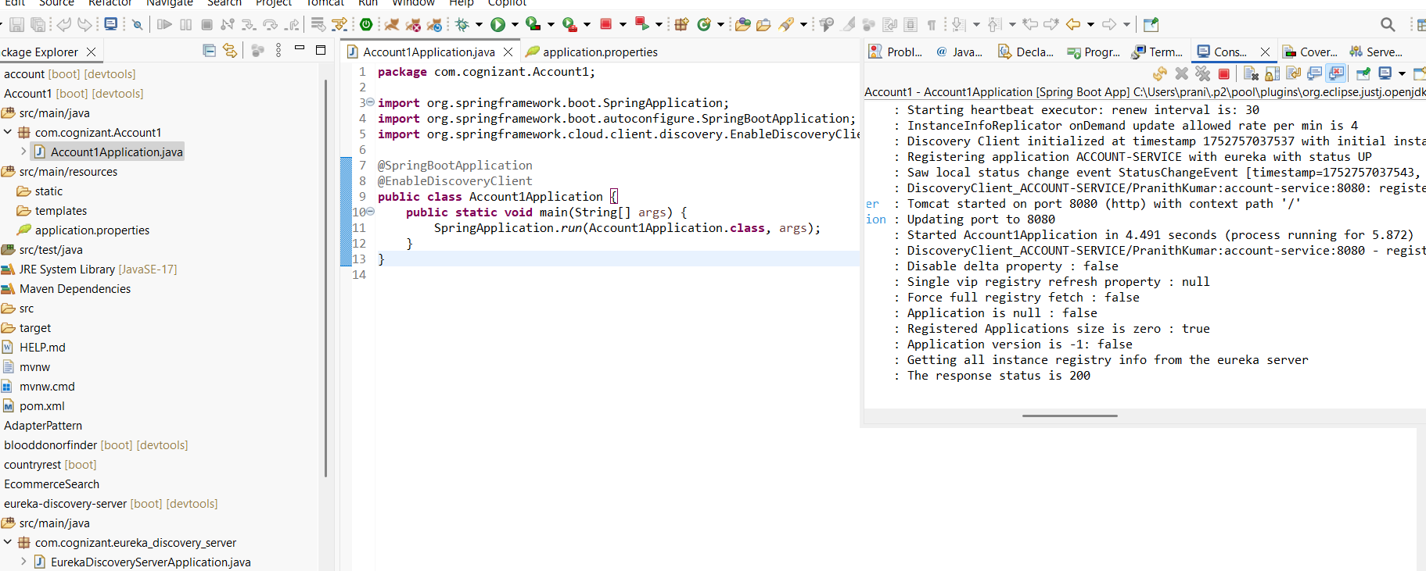

**For Loan:**

**LoanApplication.java:**

**package** com.cognizant.Loan1;

**import** org.springframework.boot.SpringApplication;

**import** org.springframework.boot.autoconfigure.SpringBootApplication;

**import** org.springframework.cloud.client.discovery.EnableDiscoveryClient;

@SpringBootApplication

@EnableDiscoveryClient

**public** **class** Loan1Application {

**public** **static** **void** main(String[] args) {

SpringApplication.*run*(Loan1Application.**class**, args);

}

}

**application.properties:**

server.port=8081

spring.application.name=loan-service

eureka.client.service-url.defaultZone=http://localhost:8761/eureka

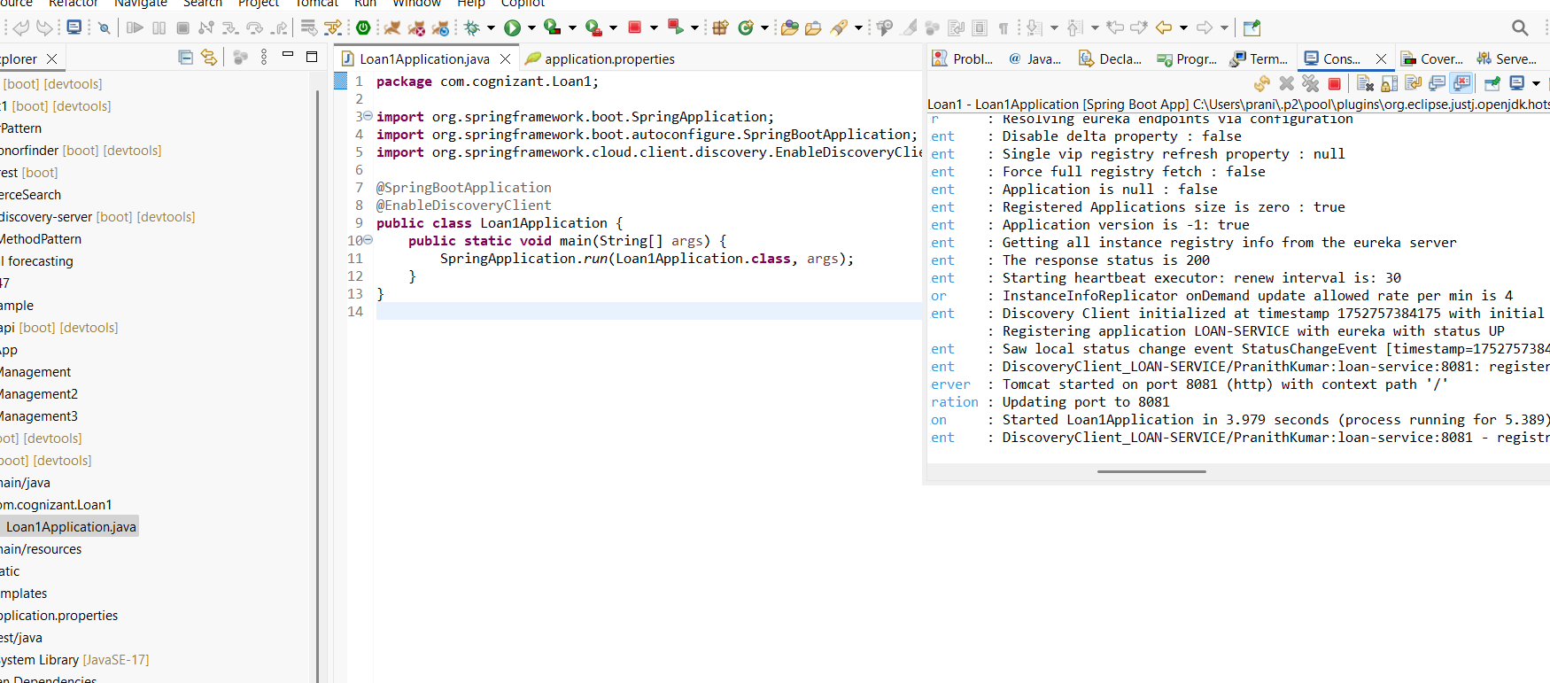**OUTPUT:**

**IN BROWSER:**

